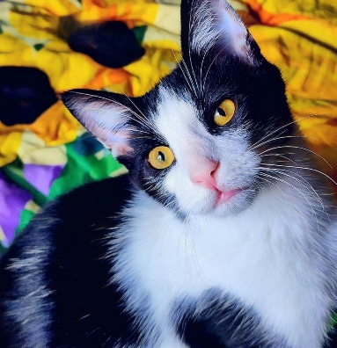
NAME: Loki and Barry
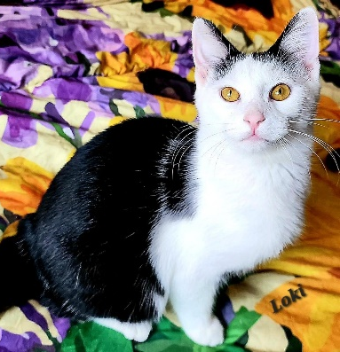
GENDER: Male
DATE OF BIRTH: October 24, 2025
Barry
FUR LENGTH: Short
COLOR: Black and white

Purrsonality: Loki is big, confident and handsome. He also loves the laser toy. He's not a big fan of wet food. He LOVES water. He would wait for his foster to turn on a faucet with a bowl underneath multiple times a day. Loki will stick his whole head underneath the running water. He loved to get in the tub with his foster and drink from the running water. Barry is a Love Bug! He loves to sleep around your head and face and make biscuits. We suggest keeping his nails trimmed due to his kneading. He loves to give kisses. He also loves laser toys and wand toys.
Children? Loki and Barry would do well with kids of all ages.
Other cats? Loki and Barry do well with other friendly cats.
Dogs? Loki and Barry have never been around dogs but should do OK with calm, friendly dogs after slow introductions.
Background: Loki and Barry were rescued with their sister, Sissy, from behind a Harpers Ferry bank after their feral mother had given birth. They were in foster until they were old enough to be adopted.
Medical or special care notes: Loki and Barry tested negative for FeLV and FIV and have been microchipped. They have had rabies and distemper vaccines and been neutered. They would do best with a water fountain but Loki may splash so putting a cookie sheet or something to catch the water under the fountain may be required. They are eating Fancy Feast classic pate and Purina One Indoor Advantage turkey kibble at Meows Corner.

