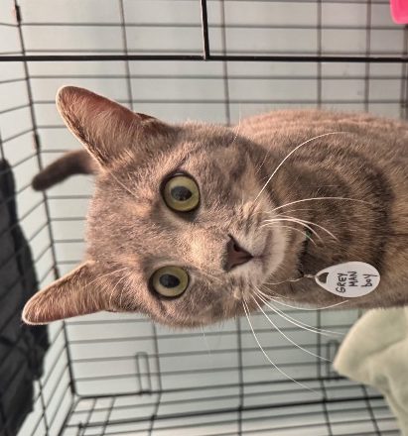
NAME: Grey Man
GENDER: Male
DATE OF BIRTH: March 31, 2023
FUR LENGTH: Short
COLOR: Gray tabby
Purrsonality: Grey Man is a handsome and large young adult that “volunteers” at Meows Corner as a guest greeter. He sits at the inner door and waits to see who is coming in to play with everyone. He likes rolling over for tummy rubs and playing with his people and cat toys. He could tolerate a high-energy home. Grey Man also likes passing the time watching the birds and squirrels outside.
Children? Grey Man would do well with kids of all ages.
Other cats? Grey Man would love to have cat friends but can go as a single cat.
Dogs? Grey Man has never been around dogs but should do OK with calm, friendly dogs after slow introductions.
Background: Grey Man and two cat friends appeared a few miles from a West Virginia rescuer’s house late 2023. A person living along the road housed them in his garage and fed them for 2 years. When he passed away, his family needed to rehome the cats to sell the property. The two other cats were adopted, and Grey Man was sent to 4Paws for the café.
Medical or special care notes: Grey Man tested negative for FeLV and FIV and has been microchipped. He has had rabies and distemper vaccines. He has been neutered. He likes both wet and dry food and will drink water from a fountain or a bowl. He is eating Fancy Feast classic pate and Purina One Indoor Advantage turkey kibble at Meows Corner.

