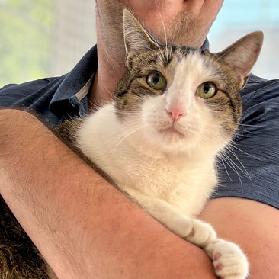
Jamie Long is as kind as he is calm. He was found outside wandering from home to home, looking for food and pets. He was in excruciating pain and needed three teeth extracted, but you would have never known because he is so gentle, patient and affectionate. Now that he is free from pain and not outdoors, he is ready to start his next chapter! Estimated birth date 5/9/2022

Wonderfully patient with young children, he loves to roll around and rub his scent on things or be pet until he closes his eyes and snoozes. He likes to be held but prefers to be pet on the ground. He doesn't jump at the sound of dogs barking nearby. He has good litter box habits, is friendly around other cats and is not jumpy around loud noises. He is neutered, up to date on rabies and distemper vaccines, negative for a combo test, and dewormed. He is ready for a kind adopter to find him and give him all the love he deserves! He is extremely easygoing and adjusts quickly to changes.

