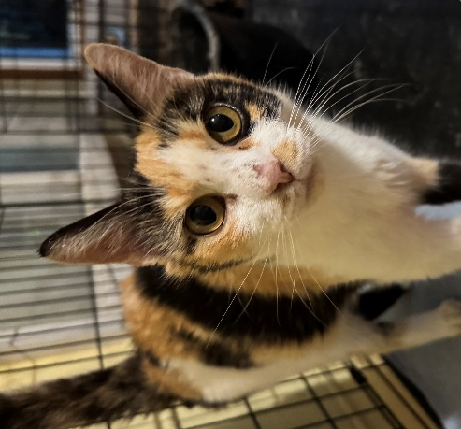
NAME: Patches
GENDER: Female
DATE OF BIRTH: June 5, 2014
FUR LENGTH: Short
COLOR: Calico

Purrsonality: A petite and gentle calico cat with a vibrant patchwork of orange, black, and white fur, Patches is an absolute social butterfly who greets everyone she meets. With purrs and expressive eyes, she actively seeks out pets, approaching humans for head scratches and leaning heavily into any hand that offers affection.
Children? Patches would do well with gentle kids of all ages.
Other cats? Patches does well with other friendly cats but can go as a single pet.
Dogs? Patches have never been around dogs but should do OK with calm, friendly dogs after slow introductions.
Background: Patches was a great mother to her many, many litters. Patches was an outside kitty in West Virginia. Unfortunately, her impoverished owner couldn’t afford to vet her properly and would sell her kittens for money. Patches was rescued with what a neighbor estimated to be her 10th litter of kittens. Her vet said Patches is doing well physically but having steady, good nutrition will help her body recover from the years of stress that all her pregnancies put on her.
Medical or special care notes: Patches tested negative for FeLV and FIV and has been microchipped. She has had rabies and distemper vaccines and been spayed. She is eating Fancy Feast classic pate and Purina One Indoor Advantage turkey kibble at Meows Corner. Her adoption fee is reduced to $60 because she is over 8 years old and considered a “senior” kitty.

