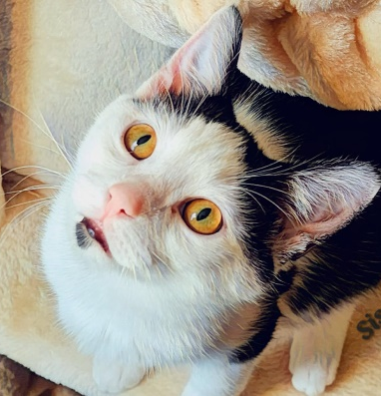
NAME: Sissy
GENDER: Female
DATE OF BIRTH: October 24, 2025
FUR LENGTH: Short
COLOR: Black and white

Purrsonality: Sissy has really turned around. She was very loving with her foster, but not always. Initially she hissed constantly and was very standoffish. One night her foster turned on videos for cats (mice, birds, chipmunks, fish, etc.). She loved it. She would come flying into her foster’s lap awaiting her videos at night. She gives kisses. She will roll around like a ferret. She loves the laser toy and would wait every night for her foster to get laser light out. Sissy will also sometimes suckle on pajamas.
Children? Sissy would do well with older children, over 10.
Other cats? Sissy would do well with other friendly cats and may benefit from the presence of another confident kitty to help her adjust to new surroundings.
Dogs? Sissy has never been around dogs but should do OK with calm, friendly dogs after slow introductions.
Background: Sissy was rescued with her brothers Barry and Loki from behind a Harpers Ferry bank after their feral mother had given birth. They were in foster until they were old enough to be adopted.
Medical or special care notes: Sissy tested negative for FeLV and FIV and has been microchipped. She has had rabies and distemper vaccines and been spayed. She has been drinking from a fountain at Meows Corner. She is eating Fancy Feast classic pate and Purina One Indoor Advantage turkey kibble at Meows Corner.

