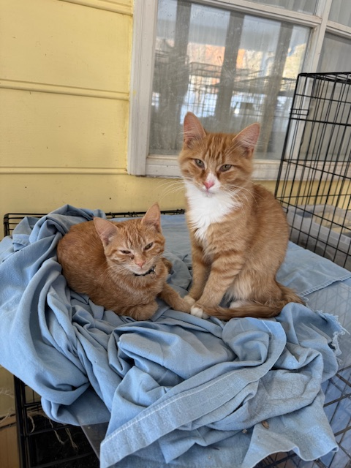
NAME: Gunther
GENDER: Male
DATE OF BIRTH: August 17, 2025
FUR LENGTH: Medium
COLOR: Orange & white
Purrsonality: Gunther is a curious, well-socialized boy that wants to play all the time. He craves toys and pounces on pretty much anything that moves. He loves catnip toys and springs but really loves it when people play with him with teaser pole toys. He is an active kitten and requires another active cat that doesn’t mind his ambushes and wrestling challenges.
Children? Gunther would make a great addition to a family with children of all ages.
Other cats? Gunther loves his sisters Creamsicle and Orangina, but they just don’t play hard enough for him. He will need another active, playful cat in his new home, and would probably do best with a male cat under 2.
Dogs? Gunther has never been around dogs but should do fine with friendly dogs after proper integration protocols.
Background: Gunther and his three sisters were found in Bunker Hill, WV with no mother. Their rescuer took them in but didn’t know how to properly care for young kittens. They were skinny and dirty, and still needed stimulation until they were old enough to use the litter box on their own. She reached out to a 4Paws partner rescue who had a foster that could care for and socialize them so they would make great indoor pets.
Medical or special care notes: Gunther tested negative for FeLV and FIV and have been microchipped. He has had rabies and distemper vaccines. He has been neutered. He likes both wet and dry food and prefers to drink water from a fountain. He is eating Fancy Feast classic pate and Purina One Indoor Advantage turkey kibble.

